Ques1: Do ping and traceroute to google.com

Ans:

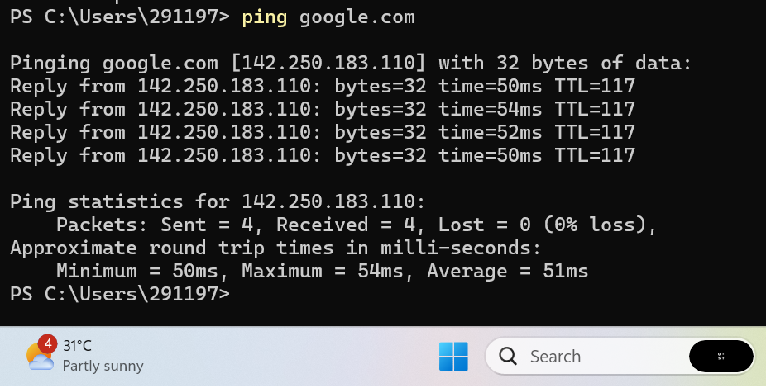

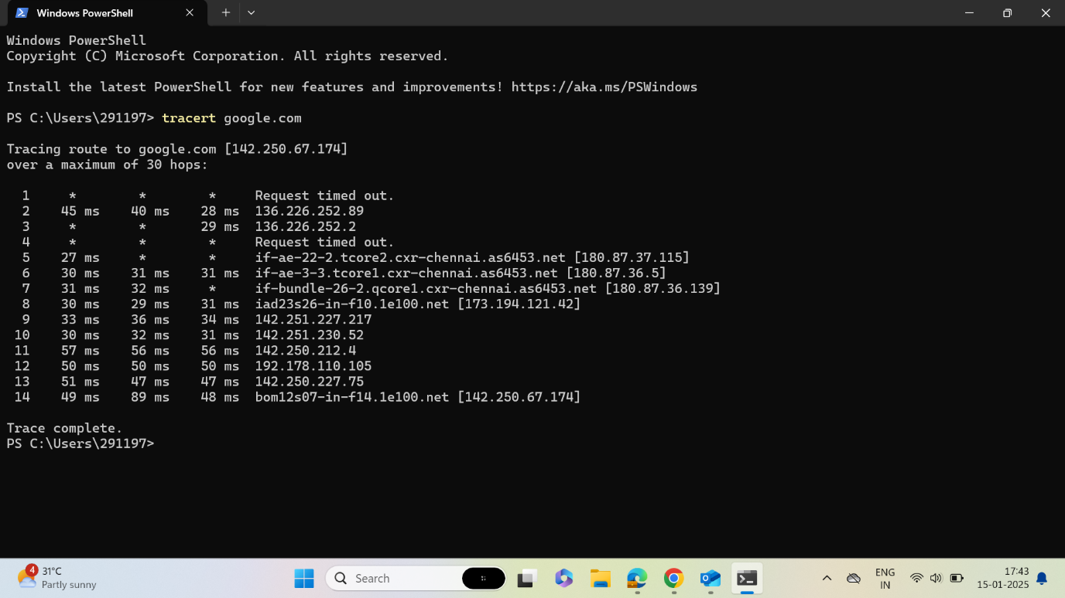

Ques2: Design a network with firewall and open ssh,http,https port to it  
Ans :  
  
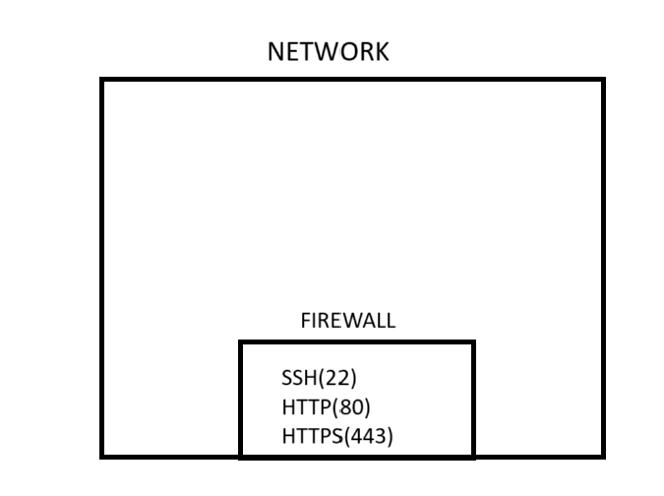  
  
  
  
  
Design a network with:

1. **Firewall**:
   * Open **ports 80 (HTTP)**, **443 (HTTPS)**, and **22 (SSH)** for incoming traffic.
   * Block all other traffic by default.
2. **Web Server**:
   * Serve HTTP/HTTPS content (Apache/Nginx).
   * Secure HTTPS with SSL/TLS.
3. **SSH Server**:
   * Allow remote access on port 22, preferably using key-based authentication and restricting by IP.
4. **Security**:
   * Restrict SSH to trusted IPs.
   * Disable root login and password authentication.

This setup ensures secure web and remote access with a controlled firewall.